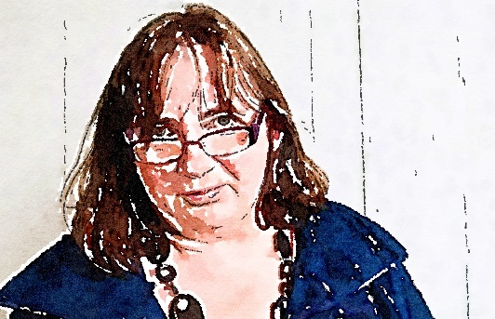
Carola Boehm, Professor of Arts and Higher Education, Staffordshire University, UK
LinkedIn Profile: https://www.linkedin.com/in/carola-boehm-79254534/
Twitter: https://twitter.com/Carola_Boehm
Email: Carola.Boehm@staffs.ac.uk
WWW: https://www.staffs.ac.uk/people/carola-boehm

I am delighted to stand for the role of Vice-Chair, a role I had the honour of holding in an acting capacity for the last few months.
I am a Professor of Arts and Higher Education at Staffordshire University and the lead of its Research Centre for Creative Communities and Creative Industries. I have held positions in various types of institutions, including old research-intensive universities, new vocationally-oriented universities and specialist institutions such as music conservatoires. Having worked and studied in the UK, Scotland, Netherlands, Denmark, Germany, Finland and the US, I am thus able to understand what it feels like to be part of the higher education sector in different parts of the world.
I am specifically proud to say I was a member right from the beginnings of the Society for Philosophy and Theory of Higher Education and have been supporting the board as a co-opted member for that time. I have run our Twitter account (@PaTHES_Society) and was for 2 years the co-lead for our online club meets. This was an initiative to provide more informal online spaces to debate relevant topics as part of our Online Club Meets. Together with PaTHES members, I am also involved in the development of special issues that emerge out of these discourses, supporting PaTHES members in their desire to publish quality articles on matters that concern us all in the society.
The Society represents for me the formalisation of structured safe-spaces where we - as academics from across the globe - can come together and debate how our sector should/might/need/will look like in the future and ensure that there is the critical mass of critical underpinnings needed to leverage the future we need. This is more important than ever in a time where we face political chaos, social unrest, disaster capitalism, climate collapse and a general lack of trust in knowledge institutions undermined by political cultures using post-truths concepts, authoritarian tropes and quite a lot of political skulduggery on top.
I am passionate about the role that universities generally play, both within their own communities and regions, as well as internationally, when meeting the challenges of our ‘new normals’. My public output includes more than 40 peer-reviewed publications, and I peer review for UK research councils and EU research frameworks. I have led on more than 20 collaborative projects, gaining funding from the EC, EPSRC, SHEFC, JISC, British Library, HEA, EU, ACE and HLF. I am a member of the Society of Research into Higher Education and the International Computer Music Association. There are significant challenges ahead for the HE sector, and we live in a time when knowledge economies around the world are debating the role of their own institutions. Being immersed in these debates and publishing on these, I would be delighted to bring my enthusiasm for and experience within the sector to the board.
Thus I would welcome to be part of the board to continue to contribute to the board’s efforts to allow debate and critical discourses around the role of our key knowledge institution – our university sector - to flourish.

Bibliography:
- BOEHM, C. (2022) Arts and Academia: The Role of Arts in Civic Universities. Emerald: Great Debates in Higher Education. https://eprints.staffs.ac.uk/7301/
- BOEHM, C (2022), Squids, University 3.0 and Activism. In: Journal for Philosophy and Theory in Higher Education, Special Issue: Academic Activism. (9 pages) https://eprints.staffs.ac.uk/7302/
- BOEHM, Carola (2021) A letter to those leading universities for the future. (WONKHE BLOG ARTICLE)
- BOEHM, Carola (2019) Environment trumps content: university in the knowledge society [Blog post]. WONKHE, WONKHE - the home of higher education policy. (WONKHE BLOG ARTICLE)
- BOEHM, Carola (2019) The end of a Golden Era of British Music? Exploration of educational gaps in the current UK creative industry strategy. In: Innovation In Music: performance, production, technology and business. Taylor & Francis/Routledge. (JOURNAL ARTICLE)
- Hepworth-Sawyer, Russ, Hughes, Nic, Ziemba, Dawid and BOEHM, Carola (2018) The discipline that ‘became’: developments in music technology in British higher education between 2007 and 2018. Journal for Music, Technology and Education. ISSN 17527066 (JOURNAL ARTICLE)
- BOEHM, Carola (2016) Music Industry, Academia and the Public. In: Proceedings of the 42nd International Computer Music Conference 12-16 September. HKU University of the Arts, Netherlands, pp. 90-97. ISBN 978-0-9845274-5-8 (PROCEEDINGS FULL ARTICLE)

